**Holy Paladin Setup Guide**

Healer profiles require a bit more setup than your typical DPS profiles. Make sure to check through these tabs to get started.

General Tab

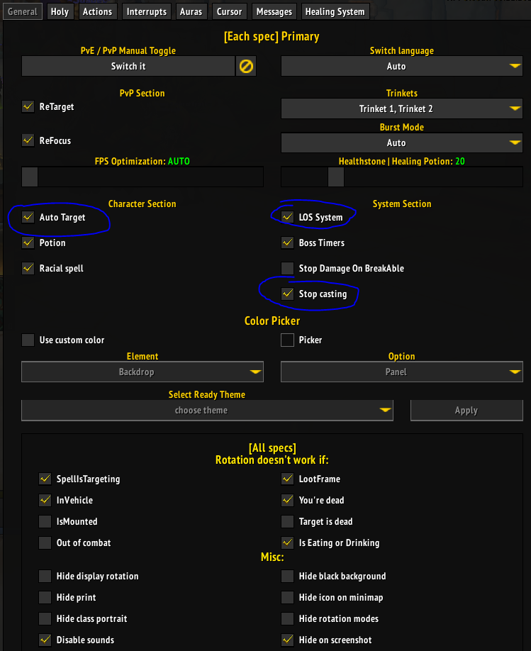

I recommend keeping **AutoTarget** on, but I also have a toggle for this.

**LOS System** I recommend keeping off in general. LOS System will ignore group members for a set time if spells repeatedly fail to get sent. This is more relevant in content where your group gets split like in a boss fight where tentacles come down and split groups in two. The current season doesn’t have fights like this.

**Stop Casting** should stay on.

**Holy Tab**

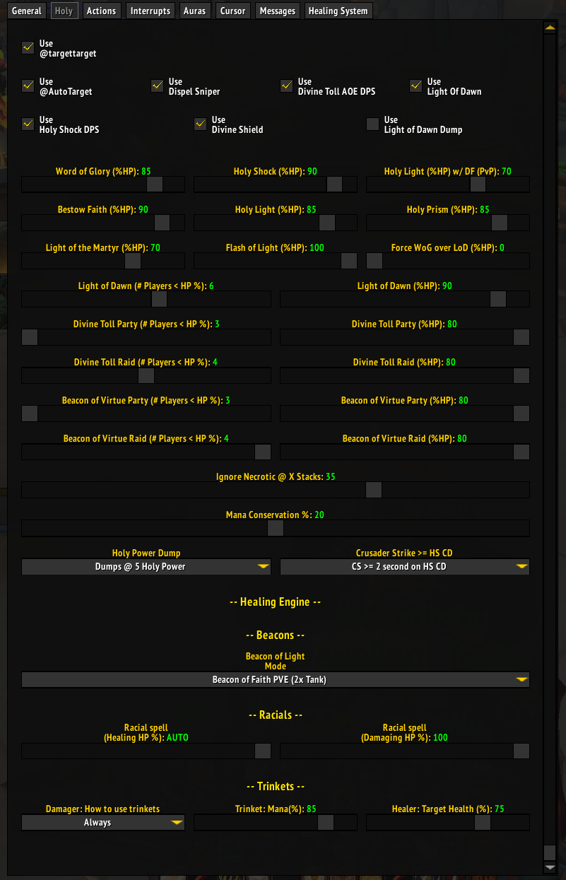

I recommend setting a keybind toggle for **Dispel Sniper.**

I also turn **Use Light of Dawn** and **Holy Shock DPS** on and off depending on if it’s party or raid content.

**Mana Conservation** slider will affect usage of some spells. I keep mine at 20%.

**Beacon of Light Mode** is set depending on content/talent. Beacon of Virtue isn’t affected.

**Crusader Strike >= HS CD** doesn’t do anything currently. I just coded it to >1.5s on HS CD.

**Auras**

Dispel Magic

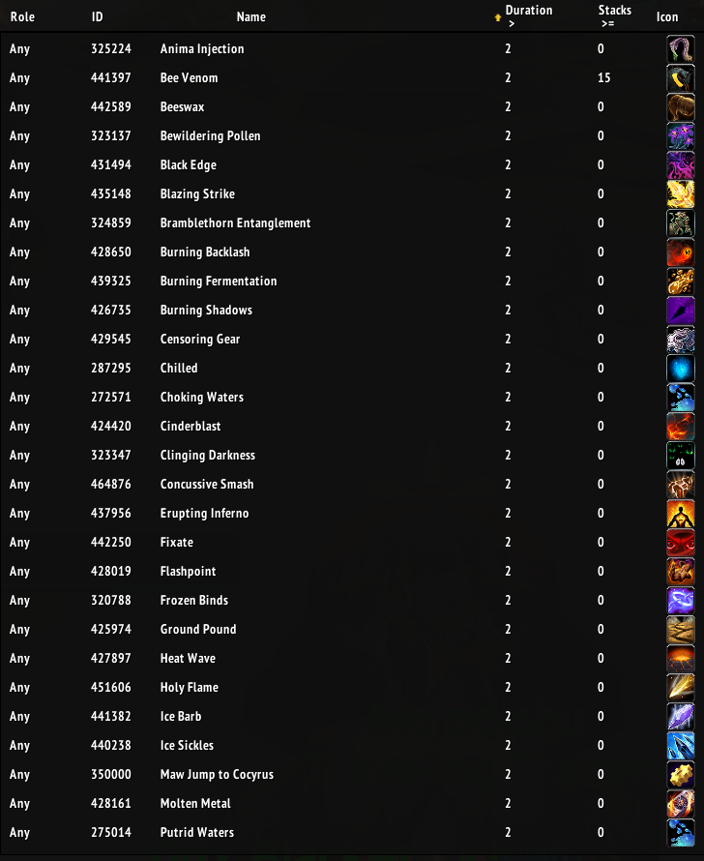

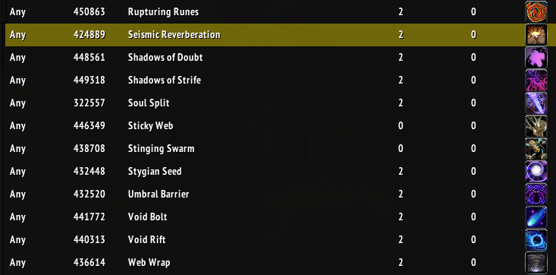

Dispel Poisons

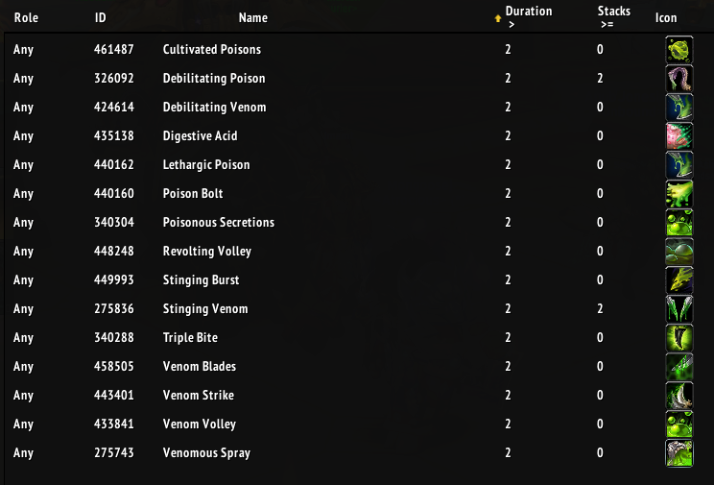

Dispel Diseases

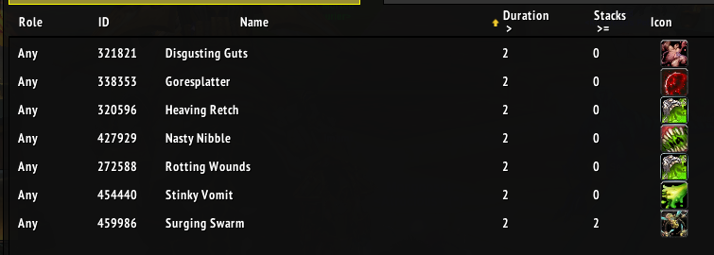

Blessing of Freedom

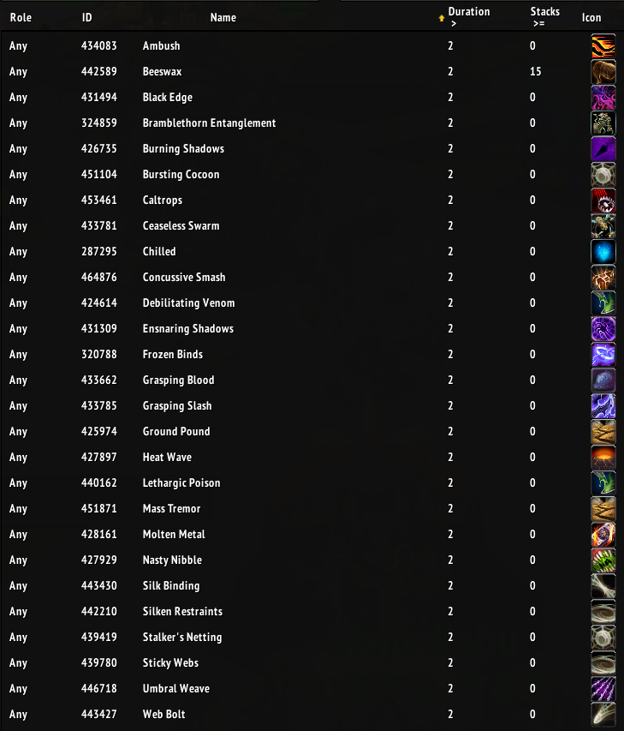

Make sure you’re putting your Auras in PVE mode, not PVP. Optionally, you can have these done quickly if you just paste in my spellID list in WTF/Action settings into the correct part of your WTF/Action settings.

**Healing System Tab**

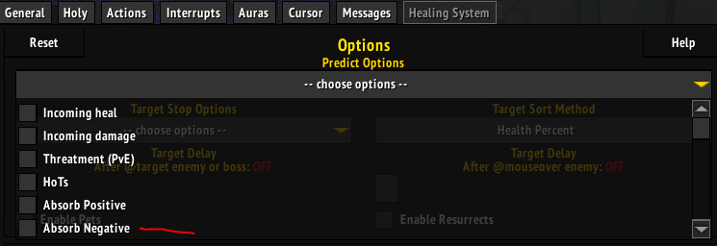

In prediction options, this will determine how the Healing Engine prioritizes targets. I typically keep all options off but Negative Absorbs (absorbs that prevent healing) are more significant in current content so some are opting to turn on Absorb Negative. So far I haven’t had any issues without it on but I’m only healing +10s and others have experience pushing higher and say it’s a bigger deal later on.

Otherwise, here’s how the rest of the settings are in this section.

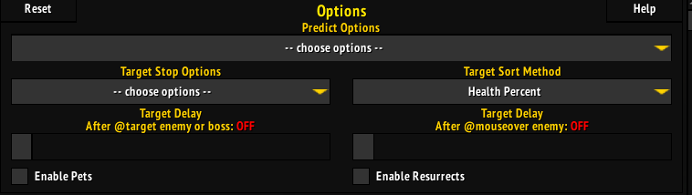

In the lower part of the Healing System tab. Here’s how I set my sliders.

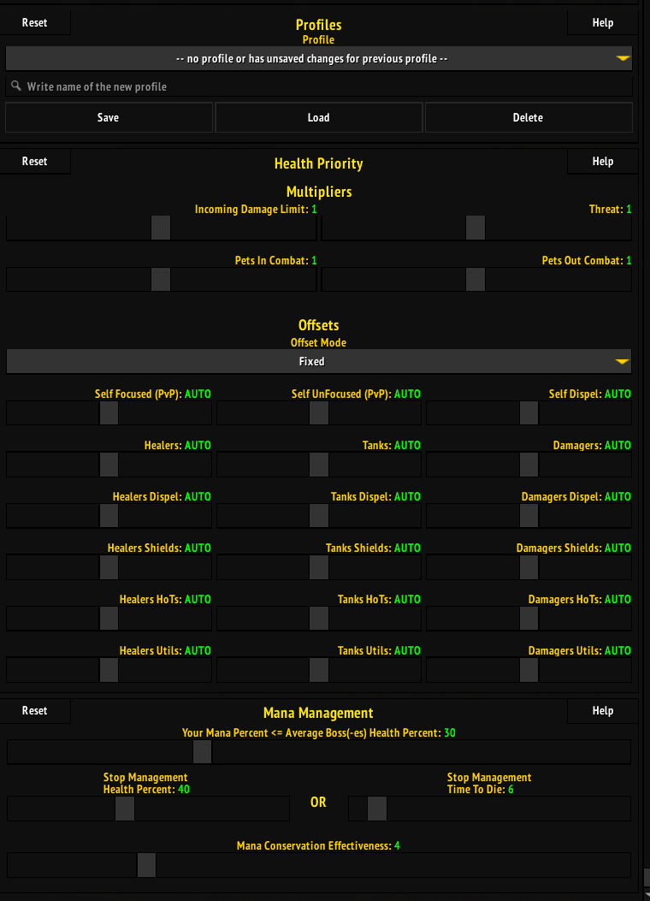

**My Toggles**

F1 - Start Rotation

F2 - Start Healing Engine

F3 - /run Action.SetToggle({1, "AutoTarget", "@AutoTarget: "}, nil)

F4 - #showtooltip Cleanse

/run Action.MacroBlocker("Cleanse")

/run Action.MacroBlocker("BlessingofFreedom")

F5 - /run Action.SetToggle({2, "DispelSniper", "Use Dispel Sniper: "}, nil)

F6 - /run Action.MacroBlocker("BlessingofProtection")

F7 - #showtooltip Lay on Hands

/run Action.MacroBlocker("LayOnHands")

**My Talent Builds**

I copy these straight from WoWHead

*Raiding*

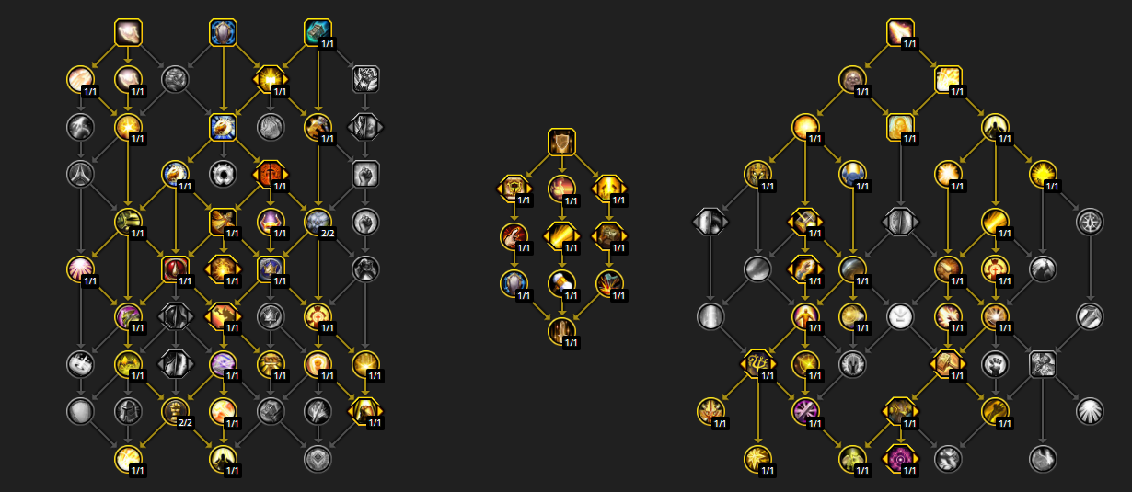

CEEAAAAAAAAAAAAAAAAAAAAAAAAAAYAAzAAAAYbmZwMmZWMzMLzMsMDYbbm2CjZMzMMwslBAMgBbAbMzMmBABAMzsst0yMDbYAsxYYMzA

*M+*

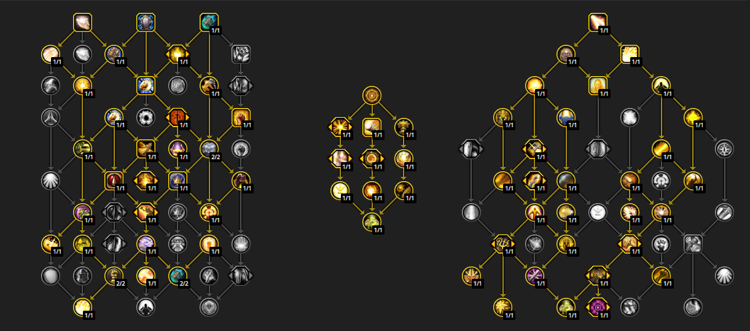

CEEAAAAAAAAAAAAAAAAAAAAAAAAAAYAAzAAAMAbjZYmxMziZMLzMjlZAbbz0WjZYMzMMwslBAMAMbAbMzMzMzysNzMLNAAgAWAmZAgxMA

**Targeting Binds**

/focus [mod:alt]party1; raid1

/focus [mod:alt]party2; raid2

/focus [mod:alt]party3; raid3

/focus [mod:alt]party4; raid4

/focus [mod:alt]player; raid5

/focus raid6

/focus raid7

/focus raid8

/focus raid9

/focus raid10

/focus raid11

/focus raid12

/focus raid13

/focus raid14

/focus raid15

/focus raid16

/focus raid17

/focus raid18

/focus raid19

/focus raid20

/focus raid21

/focus raid22

/focus raid23

/focus raid24

/focus raid25

/focus raid26

/focus raid27

/focus raid28

/focus raid29

/focus raid30

/focus raid31

/focus raid32

/focus raid33

/focus raid34

/focus raid35

/focus raid36

/focus raid37

/focus raid38

/focus raid39

/focus raid40